Key Product Sizes For 2D Design modelling
The following gives some rough sizes to use as guidance when creating your 2D Design models:
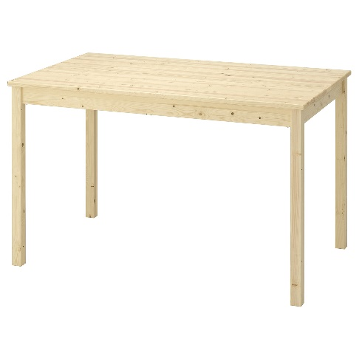15cm long x 10cm wide x 8cm high

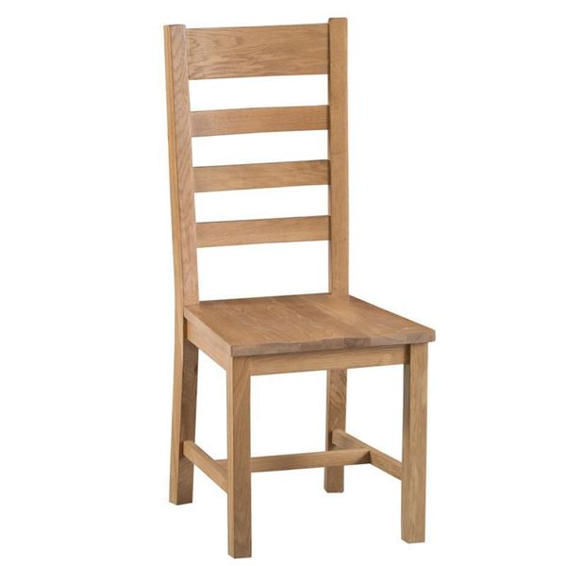20cm high x 10cm wide x 10cm depth, also 10cm to seat height

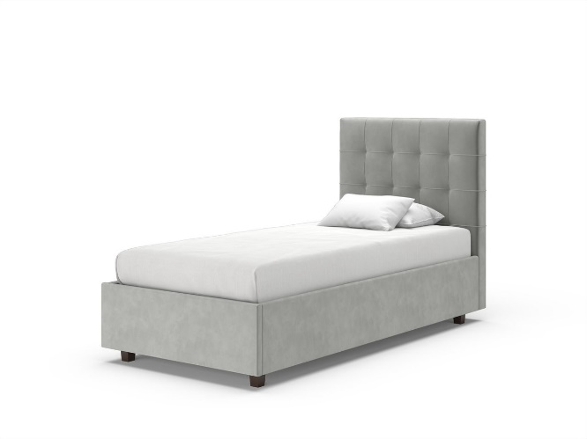
15cm long x 10cm wide by 10 high (bedhead) or 5cm high (mattress)

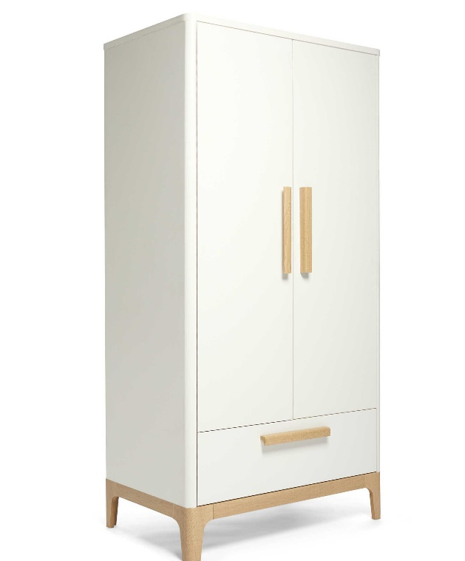20cm high x 15cm wide x 6 cm depth

